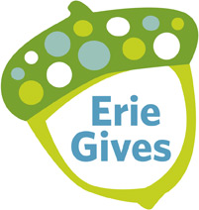
Please Consider Supporting Your Organization on August 8, 2017!
Your address Your phone number Your email
5/18/2017

«AddressBlock»
Donor Address

«GreetingLine»
It's that time of year! Erie Gives is right around the corner and we are asking for your help. Please consider a donation to YOUR ORGANIZATION on August 8th, Erie Gives Day.
Erie Gives began in 2011 in honor of The Erie Community Foundation's 75th Anniversary. It has been an incredible success and last year raised $3,451,087 from 7,395 donors. You helped us be a part of that success as YOUR ORGANIZATION was able to raise $ ____ from ____ donors. You can help us continue that success this year!
Erie Gives 2017 will take place on August 8, between the hours of 8 a.m. and 8 p.m. During the 12 hour period of online giving, The Erie Community Foundation and other generous donors will match a percentage of your donation. All you have to do is go online at www.ErieGives.org and select YOUR ORGANIZATION as your charity of choice that day.
This year the donations made on Erie Gives will ______ (describe the potential impact to result from EG giving).
Thank you in advance for considering a donation on this unique giving day to YOUR ORGANIZATION.
If you have any questions, please feel free to contact ______
Sincerely,
YOUR LEADERSHIP
Please Consider Supporting Your Organization on August 8, 2017!

